Reflective Reading Resource Pack 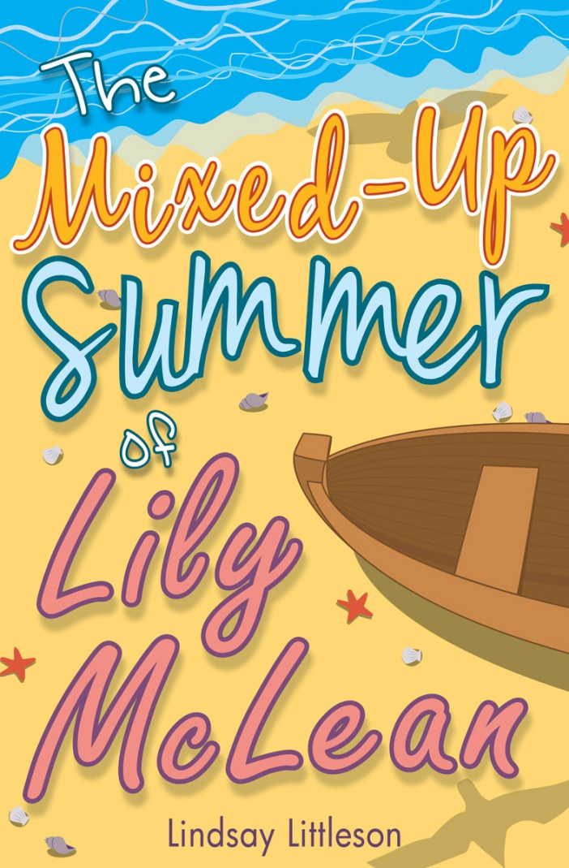

The Mixed Up Summer of Lily McLean

By Lindsay Littleson

* **Writer’s craft**
* **Talking and Listening activities**
* **HOTS Questions**
* **Creative writing projects**
* **Cross-curricular links**
* **Photocopiable activities**

**Chapter 1**

Extract from Chapter 1 {edited}

For now, though, our house is enough of a war zone without worrying about him. Jenna’s words are bouncing off the walls like grenades.

“I am not going to Millport! You might as well just kill me now! I hate you and I hate this stupid house!” she screams.

Mum’s replies are machine gun staccato. And suddenly, adding to the din, there’s a deafeningly high-pitched wail like an air raid siren.

“Mum! Bronx has the remote and he won’t give it to me and I don’t want to watch Ben 10. I want to watch the Spiderman DVD. Mum! It’s not fair! Mum!”

Oh great. Now Hudson has joined in. Let World War Three commence.

*Read the extract and highlight the war related imagery the author has used in this passage. Continue the argument, using similar imagery.*

**................................................................................................................................**

**................................................................................................................................**

**................................................................................................................................**

**................................................................................................................................**

**................................................................................................................................**

**................................................................................................................................**

**................................................................................................................................**

**................................................................................................................................**

**...............................................................................................................................**

**Extract from Chapter 1**

Finally, there’s the living room, which is in dire need of a 60-minute makeover. It has a swirly lime green carpet, floral patterned peach curtains and lumpy textured wallpaper. It’s in here that Bronx and Hudson watch cartoons and play Xbox and fight with each other, while baby Summer howls in her play pen and Mum and I try and eat our dinner and hear the television above the racket.

Read the description of the living room. Draw and label a picture of it.

Include all the details which the author has described.

**Write a short description of a room in your own home. ................................................................................................................................**

**................................................................................................................................**

**................................................................................................................................**

**................................................................................................................................**

**................................................................................................................................**

**................................................................................................................................**

**Read Chapter 2 and answer the questions. Remember to include evidence from the text in your responses.**

|  |
| --- |
| **Why does Lily have mixed feelings about going on holiday in the last week of term?**  **................................................................................................................................................................................................................................................................................................................................................................................................................................................................**  **................................................................................................................................................................................................................................**  **.................................................................................................................................................................................................................................** |
| **Why is Rowan not allowed to visit Lily’s house?**  **..........................................................................................................................................................................................................................**  **..........................................................................................................................................................................................................................**  **..........................................................................................................................................................................................................................** |
| **Lily loves lists.**  **Write a list of reasons why you like or don’t like where you live.** |

**Chapter3**In these edited extracts Lily is describing her best friend Rowan.

*Rowan Forrest has a sweet, round, freckled face with big, sparkly hazel eyes. Her brown curls are blowing in the wind and she’s dressed in cute denim cut offs and a bright yellow t-shirt...she looks so smiley that I can’t help smiling straight back. Rowan is the loveliest person in the world and it’s a criminal offence to feel jealous of her.*

*I... remind myself that I am a strong person. Rowan is always telling me that. It’s one of the reasons I love her so much. She is completely honest and always says what she feels, like Anne of Green Gables, and unlike me. If Rowan tells you something about yourself, you’re sure it must be true.*

* Discuss with your partner. What is most important to you in a friend: loyalty, generosity, honesty? Why?
* Write a short description of your best friend. Remember to mention the qualities that make them a good friend.

..................................................................................................

..................................................................................................

..................................................................................................

..................................................................................................

..................................................................................................

..................................................................................................

**Read Chapter 3 and answer the questions. Remember to include evidence from the text in your responses.**

|  |
| --- |
| **Why is Lily scared when Rowan calls her name? Write two phrases the author uses to show she is afraid.**  **................................................................................................................................................................................................................................................................................................................................................................................................................................................................**  **................................................................................................................................................................................................................................**  **.................................................................................................................................................................................................................................**  **..............................................................................................................................................................................................................................** |
| **................................................................................................................................................................................................................................** |
| **Why do you think Summer is so happy to be outside in the ‘Big Wide World’?**  **...............................................................................................................................................................................................................................**  **................................................................................................................................................................................................................................** |
| **Give two reasons why Lily doesn’t tell Rowan about the ghostly voice.**  **...............................................................................................................................................................................................................................**  **................................................................................................................................................................................................................................**  **................................................................................................................................................................................................................................**  **...................................................................................................................................................................................................** |

**Chapter 4: Writer’s Craft**

He would jerk around like an out of control robot.

She turns to Mum and shoos her as if she were an annoying insect.

My eyes are an odd, light grey colour, like beach pebbles.

**Circle thesimile which you think is most effective. Why do you think the author has chosen to use it?**

..................................................................................................

..................................................................................................

**Finish these sentences with effective similes of your own.**

He would jerk around like

..................................................................................................

..................................................................................................

She turns to Mum and shoos her as if she were ..................................................................................................

..................................................................................................

My eyes are an odd, light grey colour, like...........................................................................................

**Chapter 4 **

“Lily!” shouts my gran. “Come when you’re called!”

*I amble casually through to the living room, where Gran is standing, the image of a cartoon battleaxe, face grim and arms folded round her large chest, glaring at the clothes draped over the chairs and at the toys scattered on the carpet. Bronx and Hudson sit awestruck on the couch, silent for the first time today. Thank goodness they’re dressed at least. Gran is a frightening sight when she is preparing for battle.*

*“You girls should be more help to your mother,” she snaps, as Jenna slouches in behind me. “Look at the state of this place. It’s a disgrace!”*

Draw a detailed picture of Gran based on this description.

Write some interesting adjectives around your drawing which describe her appearance and personality.

......................................................................................................................................................

......................................................................................................................................................

......................................................................................................................................................

......................................................................................................................................................

......................................................................................................................................................

......................................................................................................................................................

......................................................................................................................................................

**Chapter 5**

Lily hates P.E. and decides that forging sick notes might be a good plan.

**Dear Mrs McKenzie,**

**Please excuse Lily from P.E.**

**Unfortunately, she has developed a serious allergy to forward rolls.**

**Best wishes**

**Claire McLean**

**Dear Mrs McKenzie,**

**Please excuse Lily from P.E. Her leg was badly**

**mauled by a lion during a trip to the zoo at the weekend.**

**Best wishes**

**Claire McLean**

What’s your least favourite school subject? Write an imaginative ‘sick note’.

**.............................................................................................**

.......................................................

..................................................................................................

..................................................................................................

..................................................................................................

......................................................

**Read Chapter 5 and answer the questions. Remember to include evidence from the text in your responses.**

|  |
| --- |
| **Why does it irritate Lily when Rowan giggles and tosses her hair?**  **................................................................................................................................**  **................................................................................................................................**  **................................................................................................................................** |
| **“I’m pretty sure they’ll live...” Why do you think Lily finds it difficult to take the other girls’ worries seriously?**  **................................................................................................................................**  **................................................................................................................................**  **................................................................................................................................** |
| Read the list at the beginning of Chapter 5.  In your own words, explain why Lily doesn’t enjoy school sport.  **................................................................................................................................**  **................................................................................................................................**  **................................................................................................................................**  **................................................................................................................................**  **................................................................................................................................**  **............................................................................................................................** |

**Chapter 7**

**This chapter begins with Lily’s list of things she will miss about primary school.**

**How are you feeling about going to high school? Write two lists.**

|  |  |
| --- | --- |
| **I’m looking forward to....** | **I’m worried about.....** |
|  |  |
| **Conclusion: (do the pros outweigh the cons or vice versa?)**  **................................................................................................................................ ................................................................................................................................................................................................................................................................**  **................................................................................................................................**  **................................................................................................................................** | |

**Read Chapter 7 and answer the questions. Remember to include evidence from the text in your responses.**

|  |
| --- |
| **What does Lily mean when she says “So much for progress”?**  **................................................................................................................................**  **................................................................................................................................**  **................................................................................................................................** |
| **Read Mrs McKenzie’s little speech. Is her character assessment of Lily accurate? Give examples which prove or disprove her assessment.**  **Lily is strong and resilient:**  **................................................................................................................................**  **................................................................................................................................**  **................................................................................................................................**  **Lily is kind and patient:**  **................................................................................................................................**  **................................................................................................................................**  **................................................................................................................................** |
| **Read the chapter and find some phrases the author has used to describe how insubstantial the ghost appears.** |

**Chapter 8**

***When we arrive at the park...”***

Read the scene at the park. Use A3 paper to create a storyboard of the scene, with text, illustrations, speech bubbles and captions.

|  |  |  |  |
| --- | --- | --- | --- |
| 1. | 2. | 3. | 4. |
|  |  |  |  |
| 5. | 6. | 7. | 8. |
|  |  |  |  |

Remember the ghost is very faint and fuzzy! How will you get round that problem in your illustrations?

You can cut out the speech bubbles below and add them to your storyboard.

Lily, can you really hear

me? Is this real?

Of course I can. I’m not deaf and you keep hissing in my ear.

**Chapter 9**

I watch the big bow door clank like a monster’s jaw onto the stone ramp and spit the cars out one by one.

**Discuss with your partner the author’s use of personification in this description of the Millport ferry.**

**Continue the description, using similar imagery.**

**................................................................................................................................**

**................................................................................................................................**

**................................................................................................................................**

**................................................................................................................................**

**Draw and label a picture of the girl Lily meets on the ferry, based on evidence in the text.**

**Chapter 9**

I gaze out at the rocky foreshore, hoping for a glimpse of a grey seal, but the only wildlife I can see are the hordes of gulls and a small group of pretty sandpipers, their heads bobbing as they search for insects on the rocks. As the bus drives past an enormous lump of volcanic rock shaped like a squatting lion, I squirm with excitement in my seat. We’re nearly there!

**Look at photos of the Cumbrae shoreline. Describe what else Lily might see on her bus journey. Include a description of her feelings as she arrives in Millport.**

**...............................................................................................................................**

**................................................................................................................................**

**................................................................................................................................**

**................................................................................................................................**

**Using interesting adjectives and powerful verbs, retell the legend of Millport’s Lion Rock.**

Once upon a time, the Cumbrae elves decided to build a magnificent stone bridge to the mainland.

**................................................................................................................................................................................................................................................................**

**................................................................................................................................**

**................................................................................................................................**

**................................................................................................................................**

**Read Chapter 10 and answer the questions. Remember to**

**include evidence from the text in your responses.**

|  |
| --- |
| **Why does Lily get annoyed when Aisha says “No more racing, Lily.”**  **................................................................................................................................**  **................................................................................................................................**  **................................................................................................................................** |
| **“Anyway, Aisha would probably just say that she’s being haunted too, and her ghost is far scarier than my ghost.” What is the author telling the reader about Aisha’s personality?**  **................................................................................................................................**  **................................................................................................................................**  **................................................................................................................................**  **................................................................................................................................** |
| **“I deal with sadness by closing down and keeping quiet, not by sharing my worries with people, never mind people I hardly know.” In your opinion, is Lily’s way of dealing with sadness healthy? Explain your thinking.**  **................................................................................................................................**  **................................................................................................................................**  **................................................................................................................................** |

**Chapters 9-13**

**Your task is to create a leaflet persuading people to visit the Isle of Cumbrae for a day trip or a short break. You need to tell them about things they can do and places they can visit.**

Success Criteria

I can:

* Take notes that I can use to help me to plan my leaflet
* Discuss the elements of an effective persuasive leaflet after examining and comparing some commercially made leaflets
* Create a persuasive leaflet with an attractive layout that incorporates text details and research skills

Note taking

Scan read Chapters 9-13. Take notes under the heading ‘Places Lily visits...’

|  |  |
| --- | --- |
| Places Lily visits/finds out about when she’s on the Isle of Cumbrae. | What else do I want/need to know about this place of interest? |
|  |  |
|  |  |
|  |  |
|  |  |

**Persuasive Writing**

* Using your notes on Chapter 9-13 as a starting point, decide what else you want/need to know about things to do and places to visit on the Isle of Cumbrae.

Fill in the right hand column on your page of notes.

* Do some research using books and the internet to gather the information you need.
* Examine some commercially made leaflets and discuss audience, content and layout.
* Plan your own leaflet carefully.

Think PALL: Purpose, Audience, Language, Layout.

Purpose: What are you trying to do? What is your goal?

Audience: Who is your leaflet aimed at?

Language: What language features will you use? e.g. slogans, alliteration, adjectives, commands.

Layout: How are you going to set out your leaflet? What colours, pictures and graphics will you use?

Useful websites

<http://www.millport.org/>

<http://www.millportonline.co.uk/>

<https://www.visitscotland.com/info/towns-villages/millport-p242501>

**Read Chapter 12 and answer the questions. Remember to include evidence from the text in your responses.**

|  |
| --- |
| **“I try and glare at her, but she isn’t looking my way. She has Rowan and David in her sights and delivers a killer shot.” What does this language tell you about how Lily feels about Aisha’s behaviour? What does she mean by a ‘killer shot’?**  **..............................................................................................................................**  **................................................................................................................................** |
| **How do Rowan and David feel when Lily refuses to get in the boat with them?**  **.................................................................................................................................**  **................................................................................................................................**  **.................................................................................................................................**  **................................................................................................................................** |
| **Find two or three words or phrases in the text which describe Lily’s feelings about getting in the boat.**  **............................................................................................................................**  **................................................................................................................................** |
| **‘They are going without me.’ What is the effect of the author’s use of a short sentence at the end of this chapter?**  **............................................................................................................................**  **................................................................................................................................** |

**Read Chapter 13 and answer the questions. Remember to include evidence from the text in your responses.**

|  |
| --- |
| **Why is Lily so angry with her friends? Would you have felt the same? Explain your thinking.**  **...............................................................................................................................**  **................................................................................................................................**  **...............................................................................................................................**  **................................................................................................................................**  **...............................................................................................................................** |
| **Describe in your own words what the ‘ghost’ tells Lily about her family.**  **...............................................................................................................................**  **................................................................................................................................**  **...............................................................................................................................**  **................................................................................................................................**  **...............................................................................................................................** |
| **Draw Lily’s ‘ghost’. Use the description in the text to label your drawing.** |

**Chapter 14**

*I try to scream, but a wave washes over my frozen, upturned face and cold saltwater fills my mouth. My throat and lungs burn and my limbs feel tired and heavy. Another wave slaps against my face and I panic, cry and gargle water. As the cold bites and my strength fades, I realise I’m drowning.*

‘A wave slaps against my face’ ‘As the cold bites’

**Why do you think the author has chosen to use these phrases?**

**................................................................................................................................**

**...............................................................................................................................**

**Either:**

**Continue the description of Lily’s struggle in the water. Try to maintain the author’s style and tone.**

**Or:**

**Rewrite the passage, using synonyms for each adjective and verb.**

**................................................................................................................................**

**................................................................................................................................**

**...............................................................................................................................................................................................................................................................**

**................................................................................................................................**

**................................................................................................................................**

**................................................................................................................................**

**Chapter 15 **

**Write a letter of apology from Lily to her gran.**

**Dear Gran,**

**......................................................................................................**

**................................................................................................................................**

**...............................................................................................................................................................................................................................................................**

**................................................................................................................................**

**................................................................................................................................**

**...............................................................................................................................**

**................................................................................................................................**

**................................................................................................................................**

**...............................................................................................................................................................................................................................................................**

**................................................................................................................................**

**................................................................................................................................**

**................................................................................................................................**

**................................................................................**

**Design a new cover for The Mixed Up Summer of Lily McLean**

* Look at the writing on the novel’s original cover*: title, author, publisher, blurb*
* Before you sketch your cover illustration, think about the main character and main ideas of the book.
* Decide what text should go on the front, the back and the spine.
* Next draw a rough design.
* Choose a colour scheme. Think of the title of the book. What colours might suit an autumn theme?
* Lay out your paper for the cover as below and remember that the left will be the back and the right will be the front when it is folded onto the book.
* Which way will you write on the spine so that you can read it on a bookshelf?

|  |  |  |
| --- | --- | --- |
| Back | Spine | Front |

Cross-curricular links

Art/Design:

EXA 2-03a EXA 2-07a

<http://www.deepspacesparkle.com/how-to-draw-paint-ferry-boats/>

<http://www.deepspacesparkle.com/sailboat-monotype-art-lesson/>

Health & Wellbeing:

HWB 2-01a - HWB 2-08a HWB 2-44b

Circle times on the main themes of the novel: friendship, family, transition.

<https://www.schoolbeat.org/uploads/media/CAB_Friendship_Matters-EN_01.pdf>

(specifically aimed at girls, but activities seem relevant to all)

HWB 2-17a

Water safety: what to do in an emergency / the work of the coastguard/ RNLI

<https://rnli.org/youth-education/education-resources/teaching-packs/all-aboard>

<http://www.scottishwater.co.uk/assets/education/clearer%20fresher%20learning/modules/second/water_safety_level2%20proof%205%20final.pdf>

Create a poster telling people what to do if somebody is in trouble in water.

Here’s how you can help

• Keep calm – always think before you act

• Try to get help – shout ‘’help, help’’ as loud as you can

• Reach out with a stick, a pole, a towel or clothing to pull the person to the water’s edge – always lie down when you are trying to pull someone in so that you don’t get pulled in

• If you can’t reach the person and no-one comes when you shout for help, telephone 999 or 112 and ask for help

NEVER JUMP INTO THE WATER YOURSELF!

Drama/ICT:

EXA 2-14a

In groups, co-write the script and act out a short scene from the novel.

Film the scene using i-pads.

Maths

MNU 2-10a/b/c MNU 2-09a

Plan and cost a day trip to Millport using train/ferry/bus timetables and fares

<https://www.calmac.co.uk/destinations/arran>

Social Studies: People and Place

SOC 2-07a

*I can describe the major characteristic features of Scotland’s landscape and explain how these were formed.*

Make a 3-D map of the Isle of Cumbrae

<http://www.3dgeography.co.uk/making-3d-maps>

Social Studies

SOC 2-10a

*Having explored my local area, I can present information on different places to live, work and relax and interesting places to visit.*

Create a lap book about the Isle of Cumbrae. You could include information about:

* Location, including a map
* Geography
* Main town
* Places of interest
* Historic Sites and Landmarks
* Recreation and Outdoor Activities—parks, sports, water
* Entertainment
* Climate
* Transport
* Food/drink for which the area is known.

Here are some examples of lap books:

